PROJECT PROGRESS REPORT
PROJECT PROGRESS REPORT
(Reporting No. 06 / 10)
Reporting Period: From 20/07/2026 To 27/08/2026
1. Student Information
Student Name | MAN VISHNUBHAI PATEL
Enrollment Number | 25IC03CA053
Program/Branch | MCA / ICA
Semester | 3
Contact Number | 8849948963
Email ID | 25ic03ca053@ppsu.ac.in

2. Project Details
Type | Research Project
Department/Domain | MCA (DS/ML) /AI &ML
Mentor Name | Mr. Srikant Singh
Start Date | 08-06-2026
End Date | 03-10-2026

3. Project Title
- OpenCV - Based System for Crack Identification and Width Estimation

4. Progress During the Reporting Period
A. Previous Reporting Review
Planned Task | Status | Remarks
Install & Import Libraries | Completed | Required libraries were installed and imported successfully for image processing and crack analysis.
Project Configuration | Completed | Project configuration, output directories, and OpenCV parameters were successfully configured.
Output & Mask Directories | Completed | Directories for processed images, crack masks, and annotated images were created successfully.
OpenCV Parameters | Completed | Gaussian blur, black-hat transformation, morphological processing, and crack-area parameters were configured and tested.
Pixel-to-mm Calibration | Completed | Pixel-to-mm calibration parameters were configured and integrated with crack-width estimation; validation using a known reference measurement is being completed.
Image Upload | Completed | Image upload functionality was implemented and tested for crack-image analysis.
Image Preprocessing | Completed | Image preprocessing was implemented to improve image quality and prepare images for crack analysis.
Crack Segmentation | Completed | Crack regions were segmented using image-processing and morphological techniques.
Crack Detection | Completed | Crack detection was implemented and tested on input images.
Crack Width Estimation | Completed | Crack-width estimation was implemented using detected crack regions and calibration settings.
Risk Classification | Completed | Risk-level classification is being developed using measured crack characteristics and defined severity thresholds.
Result Visualization | In Progress | Final annotated result visualization is being developed to display detected cracks, measurements, and risk information.

B. Work Completed During This Reporting Period
- Image Upload: Implemented and tested image upload functionality for crack analysis.
- Image Preprocessing: Completed preprocessing using grayscale conversion, Gaussian filtering and crack enhancement techniques.
- Crack Segmentation: Implemented segmentation to separate crack regions from the background.
- Crack Detection: Developed and tested the crack detection process using OpenCV.
- Crack Width Estimation: Implemented crack-width measurement using detected crack regions and calibration settings.
- Output Management: Generated processed images, crack masks and annotated image outputs.
- Testing: Tested the developed modules using crack images and reviewed the generated results.
C. Evidence / Deliverables Produced
Sr. No. | Deliverable / Evidence | Description / Link / Attachment
1 | Project Source Code | Updated Google Colab source code containing the implemented crack identification and width estimation modules.
2 | Image Upload Evidence | Screenshot/output showing successful upload of crack images for analysis.
3 | Pre-processed Images | Processed images generated after image preprocessing and crack enhancement.
4 | Crack Segmentation Results | Binary crack-mask outputs showing the segmented crack regions.
5 | Crack Detection Results | Output images showing the detected crack regions from the input images.
6 | Crack Width Estimation | Crack-width measurement results obtained from the detected crack regions.
7 | Pixel-to-mm Calibration | Configured calibration parameters for converting pixel-based crack measurements into millimeter.
8 | Annotated Images | Output images containing detected cracks and corresponding measurement information.
9 | Testing Evidence | Screenshots and results obtained by testing the completed modules with crack images.
10 | Project Progress Evidence | Updated project structure showing Modules 1–8 completed, with Risk Classification, Result Visualization, CSV Report, and ZIP Download remaining for further development.

Project Details:
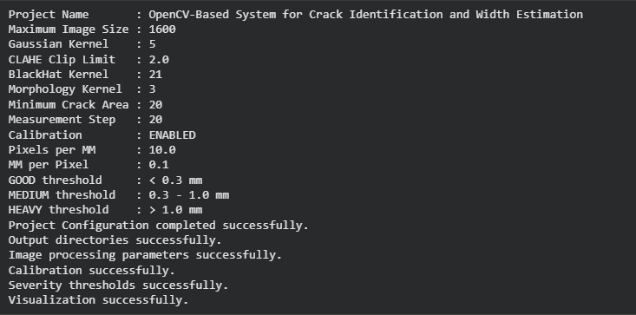
Image Upload Functions:
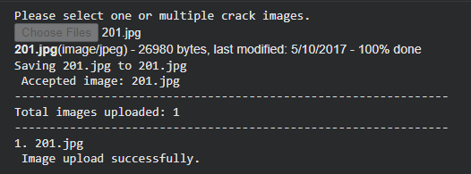
Processing Image Functions:
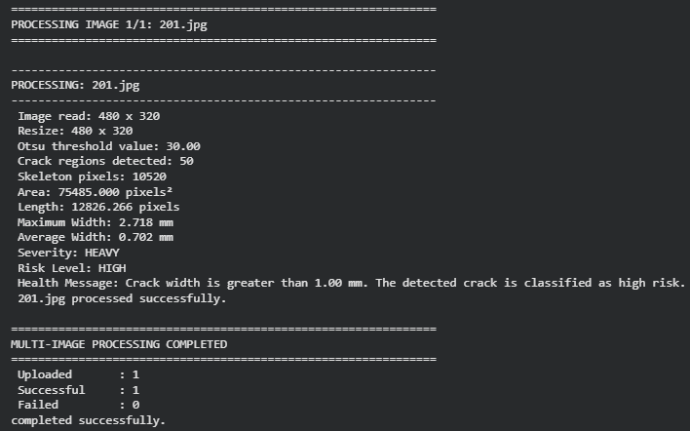

D. Current Project Progress
Overall Project Completion: 70 %
Sr. No. | Project Component | Status | Completion
1 | Library Installation | Completed | 100%
2 | Import Libraries | Completed | 100%
3 | Project Configuration | Completed | 100%
4 | Image Upload | Completed | 100%
5 | Image Preprocessing | Completed | 100%
6 | Crack Segmentation | Completed | 100%
7 | Crack Detection | Completed | 100%
8 | Crack Width Estimation | Completed | 100%
9 | Risk Classification | In Progress | 50%
10 | Result Visualization | In Progress | 50%
11 | CSV Report | Pending | 0%
12 | ZIP Download | Pending | 0%

E. Challenges / Issues Faced
- Variations in image quality, lighting, shadows, surface texture, and camera conditions affected crack detection.
- Selecting suitable image-processing techniques and OpenCV parameters required research and experimentation.
- Different crack sizes, shapes, orientations, and image resolutions made consistent analysis challenging.
- Accurate crack segmentation, thin-crack detection, width estimation, and pixel-to-mm calibration required parameter tuning.
- Multiple test images were required to identify errors and improve detection and measurement reliability.
- Integrating detection, measurement, risk classification, visualization, and reporting into one workflow required additional testing and development.

F. Actions Taken / Solution Implemented
- Applied Gaussian filtering to reduce image noise.
- Used black-hat transformation to enhance dark crack regions.
- Applied morphological operations to improve crack segmentation.
- Used minimum crack-area filtering to remove unwanted small regions.
- Implemented crack detection based on the segmented crack regions.
- Implemented crack-width estimation using the detected crack information.
- Configured pixel-to-mm calibration for physical crack-width measurement.
- Tested the developed modules with multiple crack images.

G. Plan for Next Reporting
Sr. No. | Planned Activity | Expected Deliverable | Target Date
1 | Complete Risk Classification | Low, Medium and High-risk classification results | 03 September 2026
2 | Complete Result Visualization | Annotated images with crack detection, length, width and risk information | 03 September 2026
3 | CSV Report generation | Structured CSV file containing crack analysis and measurement results | 10 September 2026
4 | ZIP Download functionality | Downloadable ZIP containing images, masks and reports | 10 September 2026
5 | Perform complete system testing and error handling | Tested and stable crack-analysis system | 17 September 2026
6 | Optimize parameters and complete final validation | Improved detection accuracy and validated results | 17 September 2026
7 | Complete project documentation and final demonstration | Final project report, presentation and demonstration-ready system | 24 September 2026

H. Learning / Skills Acquired
- Learned image pre-processing, crack segmentation, crack detection, skeletonization, crack length and width estimation, and pixel-to-mm calibration.
- Gained practical experience with Python, OpenCV, NumPy, Pandas, Matplotlib, Scikit-image, and Google Colab.
- Developed research skills through literature review and analysis of existing crack detection techniques.
- Improved problem-solving skills by handling image noise, lighting variations, thin cracks, segmentation errors, and measurement issues.
- Gained testing skills by testing image-processing modules with multiple crack images and reviewing results.
- Improved documentation skills through technical reporting, result recording, and project documentation.
- Developed teamwork and communication skills through progress discussions, technical explanations, and project presentations.

4. Tasks Accomplished
- Completed installation and import of all required Python and image-processing libraries.
- Completed project configuration and created output directories for processed images, crack masks, and annotated images.
- Implemented image upload and image preprocessing functionality.
- Implemented crack segmentation and crack detection using OpenCV-based techniques.
- Implemented crack width estimation with pixel-to-mm calibration configuration.
- Tested the developed modules using multiple crack images and reviewed the generated outputs.
- Prepared the system for risk classification, result visualization, CSV reporting, and ZIP download.
5. Tasks in Progress / Next Plan
- Complete the risk classification module using crack-width measurements and defined severity thresholds.
- Complete result visualization with detected cracks, crack length, crack width, and risk status.
- Develop CSV report generation for storing image-wise crack analysis results.
- Implement ZIP download functionality for annotated images, crack masks, processed images, and CSV reports.
- Perform complete system testing using multiple crack images and identify remaining errors.
- Optimize OpenCV parameters and improve crack detection and measurement accuracy.
- Complete final validation, documentation, project integration, and demonstration preparation.
6. Learnings / Skills Acquired
- Gained practical knowledge of OpenCV-based image processing and automated crack analysis.
- Learned techniques for crack preprocessing, enhancement, segmentation, and detection.
- Developed understanding of crack skeletonization, length measurement, and width estimation.
- Learned pixel-to-mm calibration for converting image measurements into real-world dimensions.
- Improved Python programming skills using NumPy, Pandas, Matplotlib, and Scikit-image.
- Gained experience in Google Collab, multiple-image processing, output management, and result analysis.
- Improved problem-solving, testing, debugging, and validation skills during system development.
- Developed technical documentation and research skills for presenting project methodology and results.
References:
- Ramasamy, L., & Vijayan, P. (2026). Advanced Image Processing and Deep Learning Methods for Automated Crack Detection in Civil Engineering Structures: A Comprehensive Review. Asian Journal of Civil Engineering.
- Li, Y. (2026). Crack Detection and Semantic Segmentation in Concrete Structures Using an Improved Deep Learning-Based Framework. Journal of Engineering and Applied Science, 73, 107
- Grzesiak, S., Nogatz, T., de Sousa, C., Kronenberger, M., Redenbach, C., & Pahn, M. (2026). In Situ 4D Image Analysis of Crack Width and Strain Changes in GFRP-Reinforced Concrete. Materials and Structures, 59, 197.
Evaluation (To be filled by Mentor)
Criteria | Bloom's Level | Excellent (20) | Good (15) | Average (10) | Poor (5) | Marks
Progress as per Previous Plan | L3–Apply | All planned tasks completed | Most completed | Partial completion | Very little progress
Technical / Research Implementation | L4–Analyze | Excellent implementation with clear evidence | Good implementation | Basic implementation | Insufficient evidence
Quality of Deliverables | L5–Evaluate | High-quality, validated deliverables | Good quality | Acceptable | Poor / incomplete
Problem Solving & Challenges | L4–Analyze | Challenges clearly identified and effectively solved | Most issues addressed | Limited solutions | No clear effort
Planning for Next Phase | L6–Create | Clear, realistic and measurable plan | Mostly clear plan | Basic plan | No proper plan
Documentation & Presentation | L3–Apply | Well-structured and professional | Minor issues | Average clarity | Poor documentation
Total marks out of 100

Evaluation
Student Signature | Mentor (Institute)  Signature

Mentor (Institute) Remarks
________________________________________________________________________________________________________________________________________________________________________________________________________________________________________________________________________________________________________________________________________________________________________________________________________________________________________________________________________________________________________________________________________________________________________________________________________________________________________________________________________________________________________________________________________________________________________________________________________________________________________________________________________________________________________________________________________________________________________________________________________________________________________________________________________________________________________________________________________________________________________________________________________________________________________________________________________________________________________________________________________________________________________

